

# LIBERTY ELECTRONICS

**Supervisor:** *NGUYỄN HẠ VY*

**Semester:** *01*

**Batch No:** *T3.2308.A0*

**Group No:** *05*

|  |  |  |
| --- | --- | --- |
| **Order:** | **Full name** | **Roll No.** |
| *1.* | *NGUYỄN VÕ MINH DŨNG* | Student1507640 |
| *2.* | *VÕ PHẠM THÀNH LONG* | Student1508358 |
| *3.* | *LÊ THÀNH TRUNG* | Student1507664 |
| *4.* | *NGUYỄN NGỌC TUẤN* | Student1507632 |



This is to certify that

**Mr. NGUYỄN VÕ MINH DŨNG Mr. VÕ PHẠM THÀNH LONG Mr. LÊ THÀNH TRUNG**

**Mr. NGUYỄN NGỌC TUẤN**

Have successfully Designed & Developed

**Liberty Electronics**

Submitted by: **Mr. NGUYỄN VÕ MINH DŨNG**

Date Of Issue:

22-12-2023

Authorized Signature:**Mr. NGUYỄN VÕ MINH DŨNG**

# Content

Content

Acknowledge

Synopsis

Review 1

Review 2

Review 3 ..

Tasksheet ..

# Acknowledge

As we understand that the eProject is a step-by-step learning environment that closely simulates the classroom and Lab-based learning environment into actual implementation. It is a project implementation at your fingertips!! An electronic, live juncture on the machine that allows you to.

* Practice step by step i.e. laddered approach.
* Build a larger more robust application.
* Usage of certain utilities in applications designed by user.
* Single program to unified code leading to a complete application.
* Learn implementation of concepts in a phased manner.
* Enhance skills and add value.
* Work on real-life projects.
* Give a real-life scenario and help to create applications that are more complicated and useful.
* Mentoring through email support.

First of all, I would like to thank India Aptech for allowing my team to work on this fantastic eProject. We had a great experience with eProject this time.

Next, We would like to express my special thanks to our mentor, Ms. Ha Vy for the time and effort that she provided throughout the project. Your helpful advice and suggestions were beneficial to us during the completion of the project. In this respect, We are forever grateful to you.

Besides several mistakes we made in the project, we hope to have more opportunities to widen our knowledge in the web-developing world.

We will try to continue to learn and improve ourselves even more in the future

Yours Sincerely, Team Group 05.

# Synopsis

The Objective of this program we aim is to give a sample project to work on real- life projects. These applications help us build a larger more robust application.

The objective is not to teach us HTML/JavaScript but to provide us with a real-life scenario and help us create basic applications using the tools.

Hence, we can revise the chapters before we start with the project.

This project is meant for students like us who have completed the module of HTML5. These programs should be done in the Lab sessions with the assistance of the faculty if required.

The website (in this project) is a tool that brings everything in the world to you such as historic monuments information natural knowledge and skill in technology...

It is very essential for us that will have a clear understanding of the subject. We think we should go through the project and solve the assignments as per the requirements given.

And get back [***eprojects@aptech.ac.in***](mailto:eprojects@aptech.ac.in) as the assigned schedule.

## **Problem Definition**

Liberty Electronics is a shop selling various electronic products. The company

advertises by distributing the pamphlets, advertising on television and so on. Due to

rapid development in internet field, the company decides to launch a website where

people will get all the information about the various products available with them

easily.

The website is to be developed for the Windows Platform using HTML5, JavaScript

and Geolocation. The site should work well in all leading browsers including Chrome,

IE, Firefox etc.

Requirement Specification:

The Web site is to be created based on the following requirements.

1) The Home Page should be created making use of sections with a suitable logo

2) The site should display a menu which will contain the options for brief

introduction about the various products available, location of the shop and

any other information if required.

3) The information should be categorized according to the brand names of the

products like if a User wants to see only Samsung products then he click on a

Link/button/menu etc and he will see only That Brand products.

4) When a user selects any particular brand, a list of products for that brand will

be displayed

5) A brief summary of features of individual products should be displayed on the

Web Page along with the product but detailed Features should be stored in

Individual Word documents which can be downloaded or viewed by the User

who wishes to see the same.

6) The user should also be able to compare the various products of different as

well as similar brands.

7) There should be a “Contact Us” page which will have the Address of the

Company which is as follows and the mail address which when clicked will

invoke the local mail client from where they can send an email. Address of the

Company should be displayed using GeoLocation API (eg. GoogleMaps).

## Customer Requirements Specification

### **User**:

#### **Input**:

* Information on search.
* Data of registered members.
* Feedback to web owner.

#### **Process**:

* Find the searching
* Check the data of registered members.
* Check the feedback of users.
* Check user information

#### **Output**:

* Result of searching.
* Confirm the data of registered members.
* Confirm the feedback of the users.
* Confirm the user information

## **Hardware/ Software Requirement:**

**Hardware :**

• A minimum computer system that will help you access all the tools in the

courses is a Pentium 166 or better

• 64 Megabytes of RAM or better

**Software [Either or Combination as per Course/Sem]**

• Notepad/HTML editor/CoffeeCup

• Angular / Angular JS / React / BootStrap

• Dreamweaver / Figma

• MS IE / Chrome / FireFox / Netscape /MS Edge

## **Architecture and design of the project**

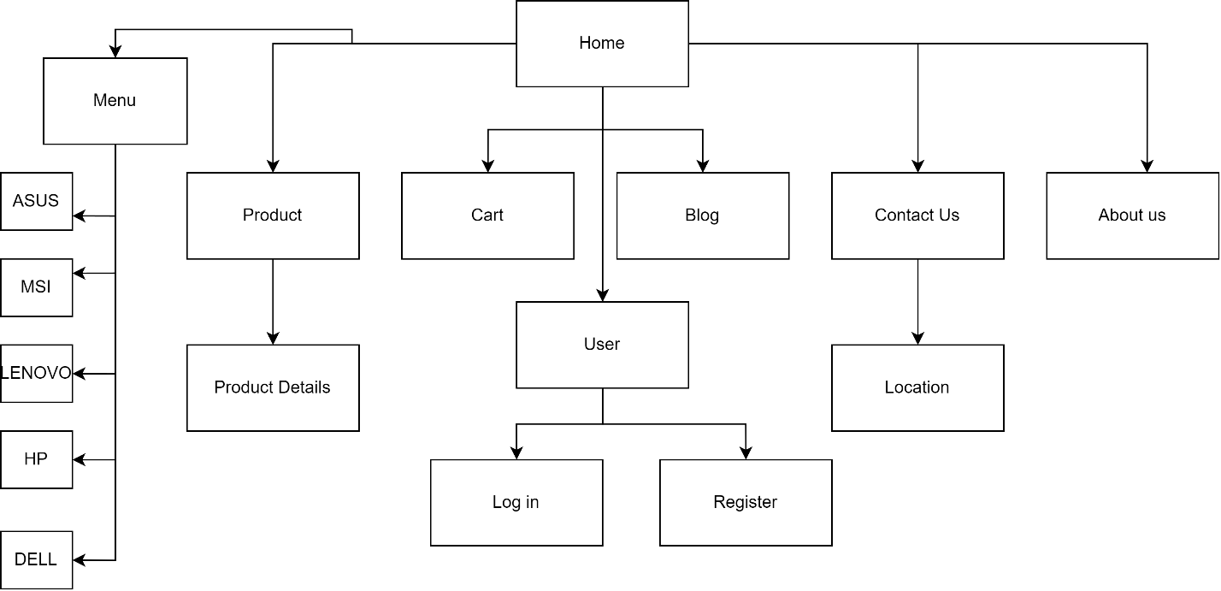

%3CmxGraphModel%3E%3Croot%3E%3CmxCell%20id%3D%220%22%2F%3E%3CmxCell%20id%3D%221%22%20parent%3D%220%22%2F%3E%3CmxCell%20id%3D%222%22%20value%3D%22Home%26lt%3Bbr%26gt%3B%22%20style%3D%22rounded%3D0%3BwhiteSpace%3Dwrap%3Bhtml%3D1%3B%22%20vertex%3D%221%22%20parent%3D%221%22%3E%3CmxGeometry%20x%3D%22360%22%20y%3D%22140%22%20width%3D%22120%22%20height%3D%2260%22%20as%3D%22geometry%22%2F%3E%3C%2FmxCell%3E%3CmxCell%20id%3D%223%22%20value%3D%22Menu%22%20style%3D%22rounded%3D0%3BwhiteSpace%3Dwrap%3Bhtml%3D1%3B%22%20vertex%3D%221%22%20parent%3D%221%22%3E%3CmxGeometry%20y%3D%22260%22%20width%3D%22100%22%20height%3D%2260%22%20as%3D%22geometry%22%2F%3E%3C%2FmxCell%3E%3CmxCell%20id%3D%224%22%20value%3D%22Product%22%20style%3D%22rounded%3D0%3BwhiteSpace%3Dwrap%3Bhtml%3D1%3B%22%20vertex%3D%221%22%20parent%3D%221%22%3E%3CmxGeometry%20x%3D%22130%22%20y%3D%22260%22%20width%3D%22120%22%20height%3D%2260%22%20as%3D%22geometry%22%2F%3E%3C%2FmxCell%3E%3CmxCell%20id%3D%225%22%20value%3D%22About%20us%22%20style%3D%22rounded%3D0%3BwhiteSpace%3Dwrap%3Bhtml%3D1%3B%22%20vertex%3D%221%22%20parent%3D%221%22%3E%3CmxGeometry%20x%3D%22730%22%20y%3D%22260%22%20width%3D%22120%22%20height%3D%2260%22%20as%3D%22geometry%22%2F%3E%3C%2FmxCell%3E%3CmxCell%20id%3D%226%22%20value%3D%22Blog%22%20style%3D%22rounded%3D0%3BwhiteSpace%3Dwrap%3Bhtml%3D1%3B%22%20vertex%3D%221%22%20parent%3D%221%22%3E%3CmxGeometry%20x%3D%22430%22%20y%3D%22260%22%20width%3D%22120%22%20height%3D%2260%22%20as%3D%22geometry%22%2F%3E%3C%2FmxCell%3E%3CmxCell%20id%3D%227%22%20value%3D%22Contact%20Us%22%20style%3D%22rounded%3D0%3BwhiteSpace%3Dwrap%3Bhtml%3D1%3B%22%20vertex%3D%221%22%20parent%3D%221%22%3E%3CmxGeometry%20x%3D%22580%22%20y%3D%22260%22%20width%3D%22120%22%20height%3D%2260%22%20as%3D%22geometry%22%2F%3E%3C%2FmxCell%3E%3CmxCell%20id%3D%228%22%20value%3D%22Cart%22%20style%3D%22rounded%3D0%3BwhiteSpace%3Dwrap%3Bhtml%3D1%3B%22%20vertex%3D%221%22%20parent%3D%221%22%3E%3CmxGeometry%20x%3D%22280%22%20y%3D%22260%22%20width%3D%22120%22%20height%3D%2260%22%20as%3D%22geometry%22%2F%3E%3C%2FmxCell%3E%3CmxCell%20id%3D%229%22%20value%3D%22Product%20Details%22%20style%3D%22rounded%3D0%3BwhiteSpace%3Dwrap%3Bhtml%3D1%3B%22%20vertex%3D%221%22%20parent%3D%221%22%3E%3CmxGeometry%20x%3D%22130%22%20y%3D%22380%22%20width%3D%22120%22%20height%3D%2260%22%20as%3D%22geometry%22%2F%3E%3C%2FmxCell%3E%3CmxCell%20id%3D%2210%22%20value%3D%22Location%22%20style%3D%22rounded%3D0%3BwhiteSpace%3Dwrap%3Bhtml%3D1%3B%22%20vertex%3D%221%22%20parent%3D%221%22%3E%3CmxGeometry%20x%3D%22580%22%20y%3D%22380%22%20width%3D%22120%22%20height%3D%2260%22%20as%3D%22geometry%22%2F%3E%3C%2FmxCell%3E%3C%2Froot%3E%3C%2FmxGraphModel%3E

1. Homepage

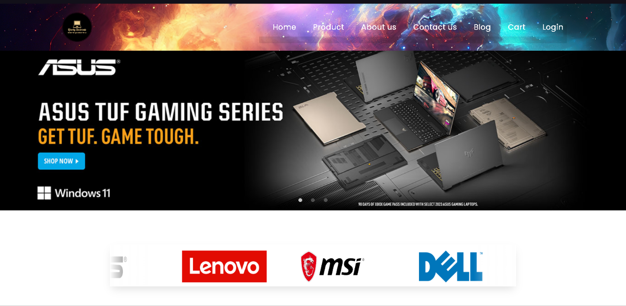

**2**

**1**

**8**

**7**

**6**

**5**

**4**

**3**

**9**

|  |  |  |  |
| --- | --- | --- | --- |
| **No.** | **Type** | **Dicsription** | **Name** |
| **1** | Click | When clicked, it leads to the Homepage. | Homepage navigation |
| **2** | Click | When clicked, it leads to products detail. | Products detail navigation |
| **3** | Click | When clicked, it leads to About us | About us page navigation |
| **4** | Click | When clicked, it leads to Contact us | Contact us page navigation |
| **5** | Click | When clicked, it leads to Blog | Blog page navigation |
| **6** | Click | When clicked, it leads to Cart | Cart page navigation |
| **7** | Click | When clicked, it leads to Login | Login page navigation |
| **8** | Click | When clicked, it leads to the Homepage. | Homepage navigation |
| **9** | Click | When clicked, it leads to the video introduce about brand | Banner navigation |

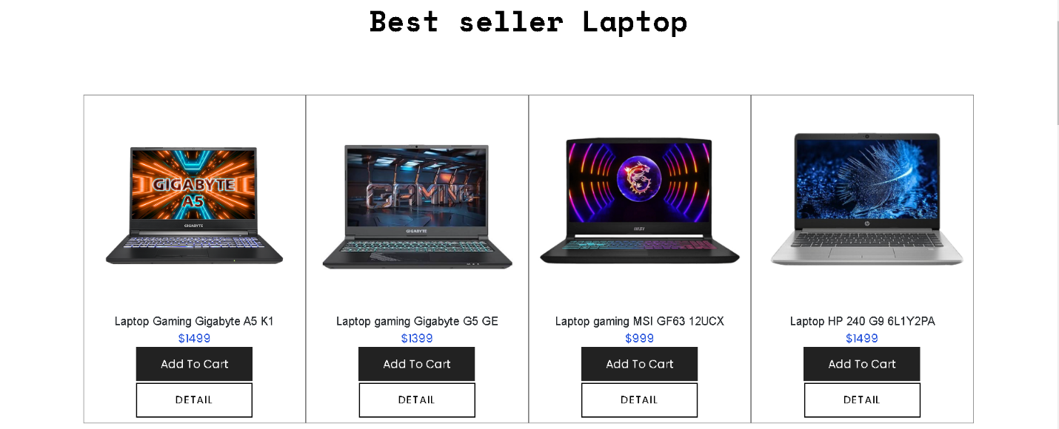

**2**

**1**

1

|  |  |  |  |
| --- | --- | --- | --- |
| **No.** | **Type** | **Discription** | **Name** |
| **1** | Click | When clicked, the product will be added to the cart | Add cart |
| **2** | Click | When clicked, it leads to the product detail | Product details page navigation |

When clicked add cart:

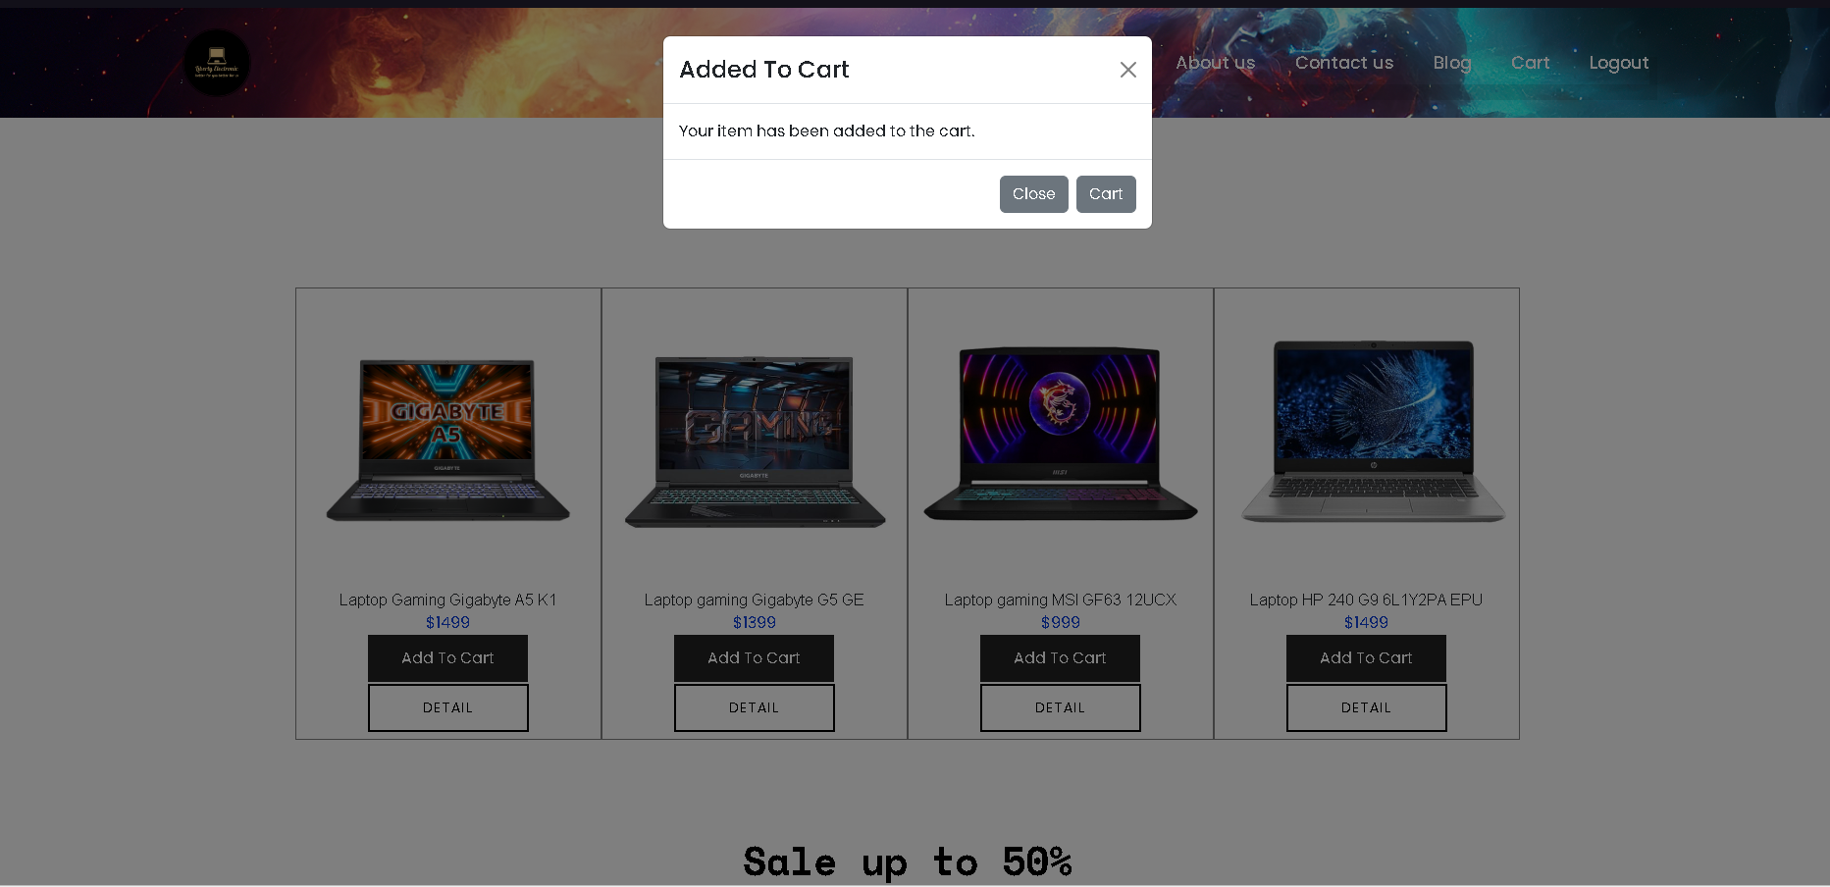

When no product in cart : 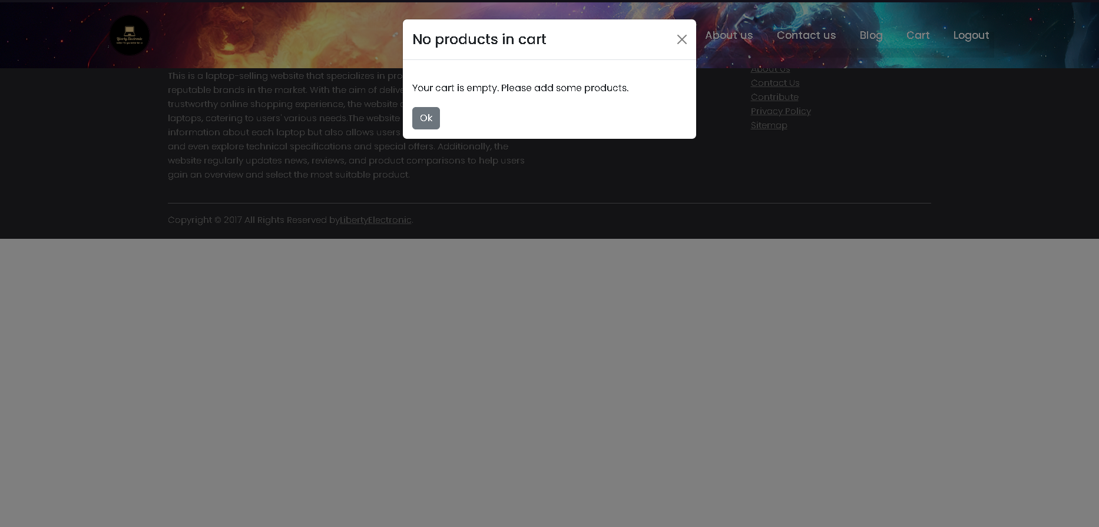

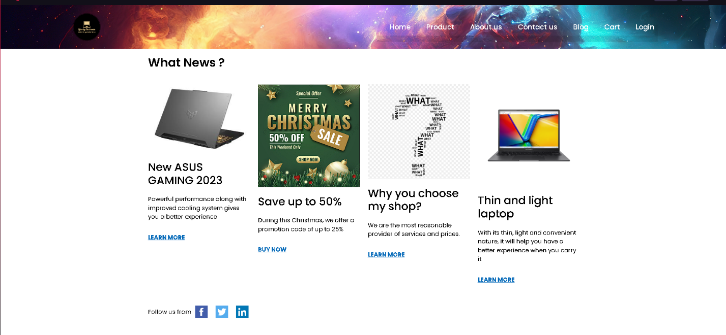

**5**

**4**

**3**

**2**

**1**

|  |  |  |  |
| --- | --- | --- | --- |
| **No.** | **Type** | **Discription** | **Name** |
| 1 | Click | When clicked, it leads to ASUS Blog | ASUS Blog page navigate |
| 2 | Click | When clicked, it leads to product list | Product list page navigate |
| 3 | Click | When clicked, it leads to contact page | Contact us page navigate |
| 4 | Click | When clicked, it leads to recommend page | Recommend page navigate |
| 5 | Click | When clicked, it leads to facebook, twitter, linked  As icon clicked | Facebook, twitter, linked page navigate |

When clicked recommend page:

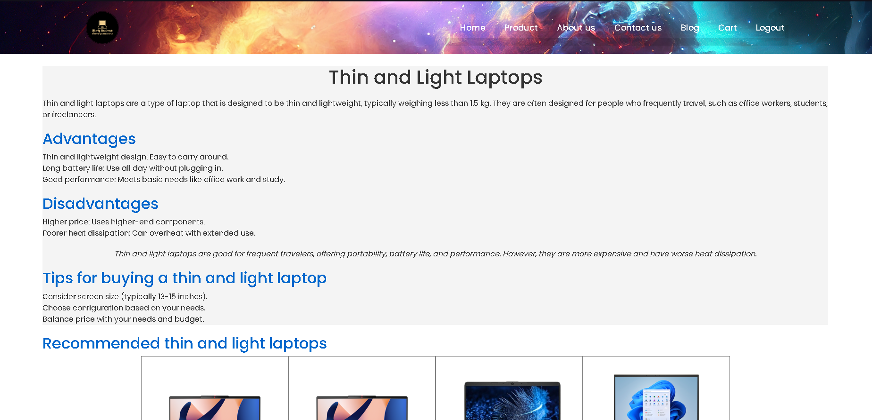

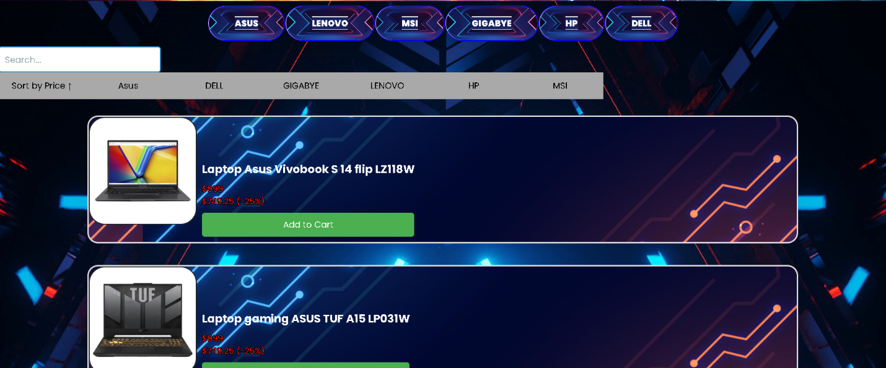

1. Product details

**1**

**2**

**3**

**6**

**4**

**5**

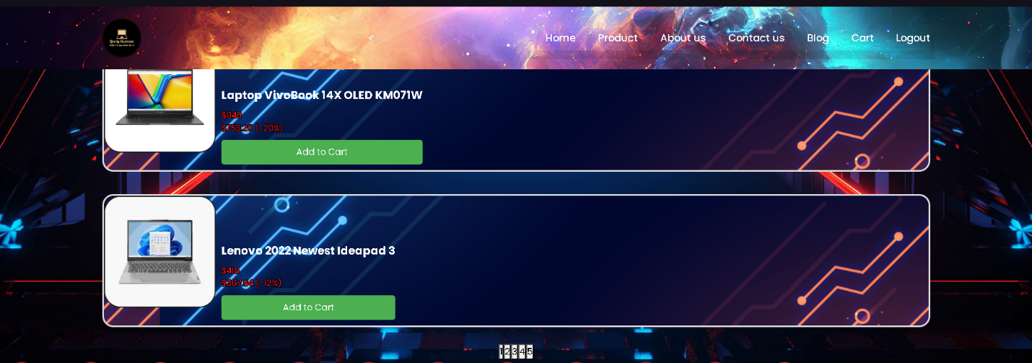

**7**

|  |  |  |  |
| --- | --- | --- | --- |
| **No.** | **Type** | **Discription** | **Validation** |
| **1** | Click | When clicked, it leads to video introduce about brand | Video brand navigate |
| **2** | Input | When entering characters, the search will be based on name | Search name |
| **3** | Click | When clicked, it leads to products about brand you clicked | Product brand navigate |
| **4** | Click | When clicked image, it leads to products detail | Product detail page navigate |
| **5** | Click | When clicked, the product will be added to the cart | Add cart |
| **6** | Click | When clicked, the product can sort by low or high price | Sort price |
| **7** | Click | When clicked, it leads to the other brand’s product page | Pagination |
| **3 + 6** | Input | Entering characters and sort by price | Search with multiple criteria |

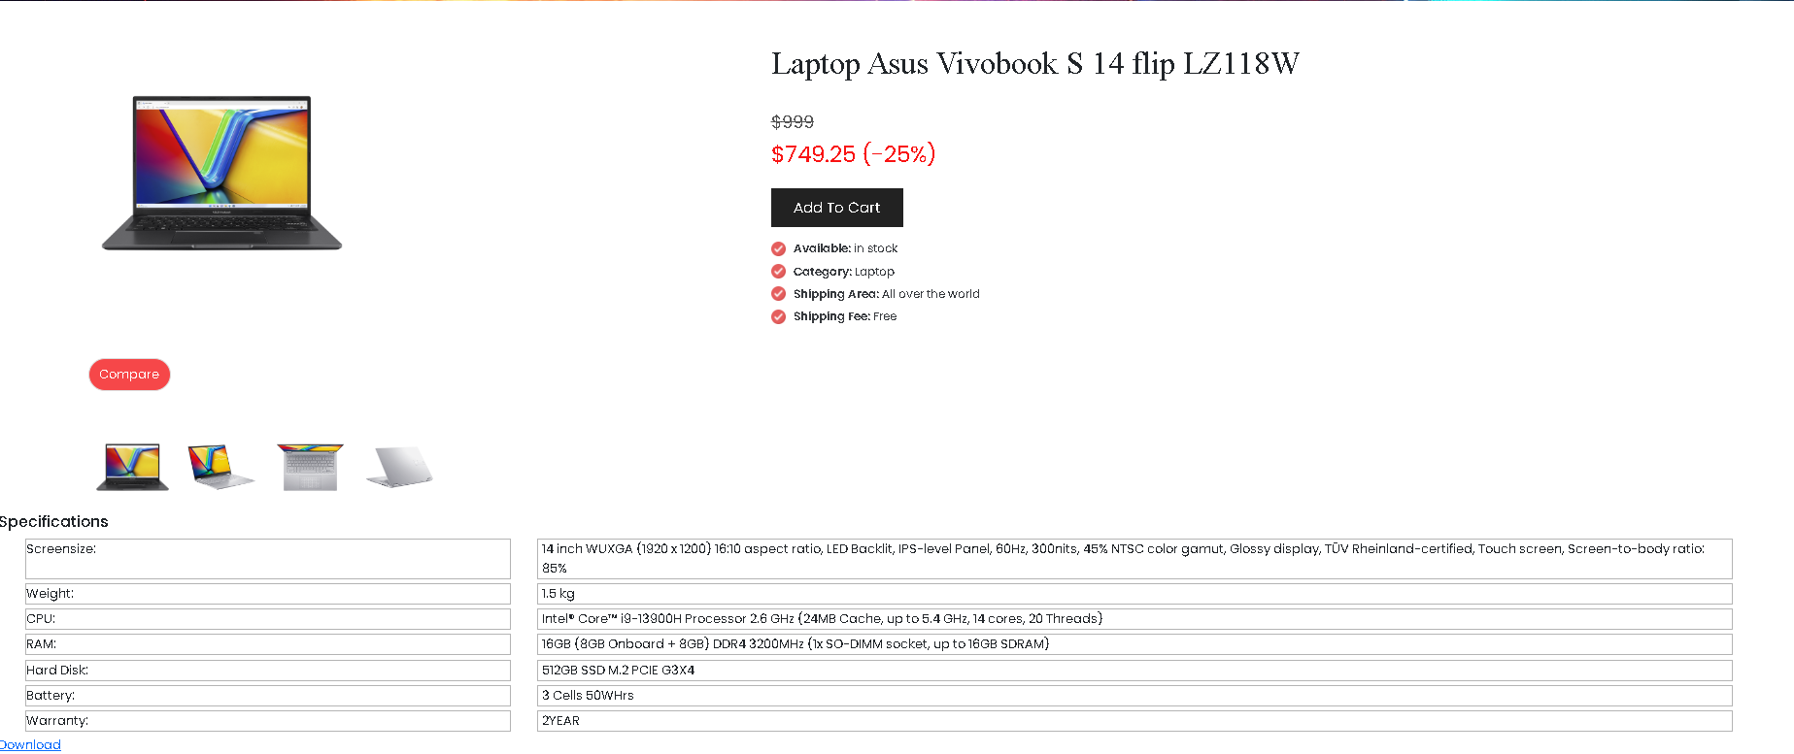

**1**

**2**

**3**

|  |  |  |  |
| --- | --- | --- | --- |
| **No.** | **Type** | **Discription** | **Validation** |
| 1 | Click | When clicked, the product will be added to the cart | Add cart |
| 2 | Click | When clicked, compare the product with other product | Compare navigate |
| 3 | Click | When clicked, downloaded product | Dowload navigate |

When clicked compare:

**2**

**1**

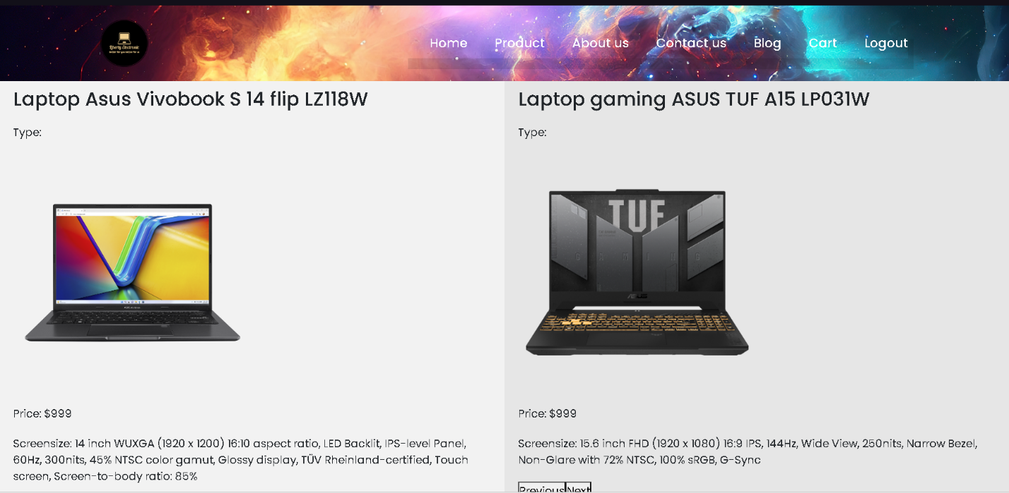

|  |  |  |  |
| --- | --- | --- | --- |
| **No.** | **Type** | **Discription** | **Validation** |
| 1 | Click | When clicked, find another previous product to compare | Previous product compare navigate |
| 2 | Click | When clicked, find another next product to compare | Next product compare navigate |

1. Contact page

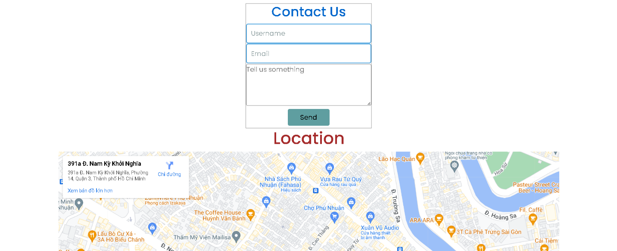

**1**

**2**

**3**

|  |  |  |  |
| --- | --- | --- | --- |
| **No.** | **Type** | **Discription** | **Validation** |
| **1** | Input | Information needed for send messages | Required Username |
| **2** | Input | Information needed for send messages | Required Email, required @ |
| **3** | Click | Send messages | Send messages navigate |

1. Blogs

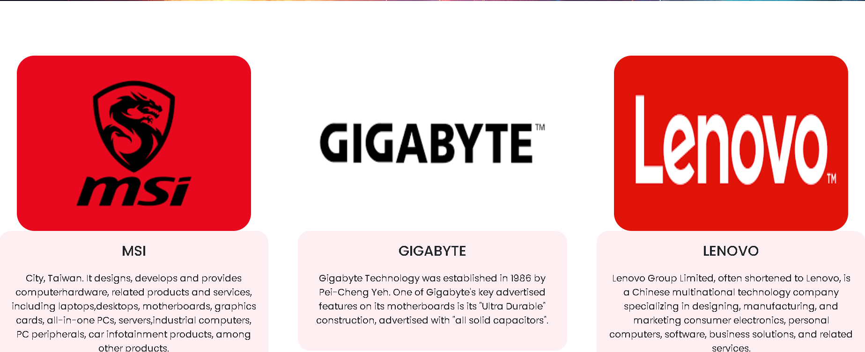

**1**

**2**

|  |  |  |  |
| --- | --- | --- | --- |
| **No.** | **Type** | **Discription** | **Validation** |
| **1** | Click | When clicked, it leads to Blog Details brand. | Blog Detail page navigate |
| **2** | Click | When clicked, it leads to Blog Details brand. | Blog Detail page navigate |

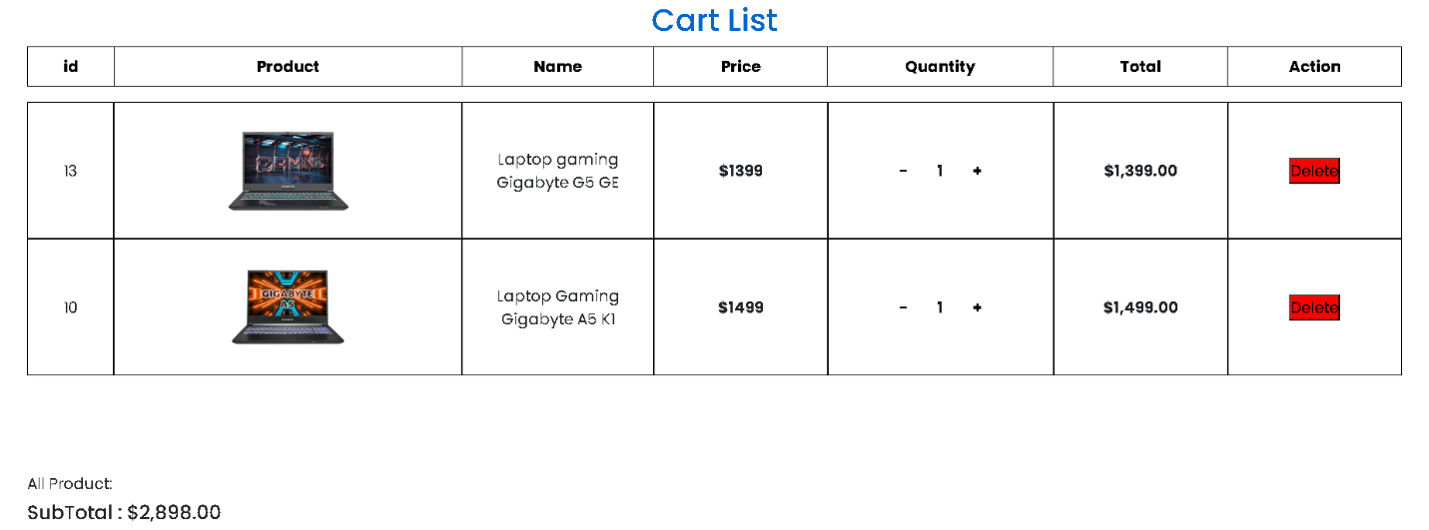

**3**

**2**

**1**

|  |  |  |  |
| --- | --- | --- | --- |
| **No.** | **Type** | **Discription** | **Validation** |
| **1** | Click | Decrease the number of products in the shopping cart | Decrease number of products in the cart |
| **2** | Click | Increase the number of products in the shopping cart | Increase number of products in the cart |
| **3** | Click | When you click on the product, it will be completely deleted | Delete cart products |

1. Login/Register



**1**

**3**

**2**

**5**

**4**

|  |  |  |  |
| --- | --- | --- | --- |
| **No.** | **Type** | **Discription** | **Validation** |
| 1 | Input | Information needed for register | Required Username, length than 8 character and capitalized word |
| 2 | Input | Information needed for register | Required password, length than 8 character and capitalized word |
| 3 | Input | Information needed for register | Required confirm password, length than 8 character and capitalized word |
| 4 | Click | Submit register | Required input all |
| 5 | Click | When clicked, it leads to Login page | Login page navigate |

When input wrong username:

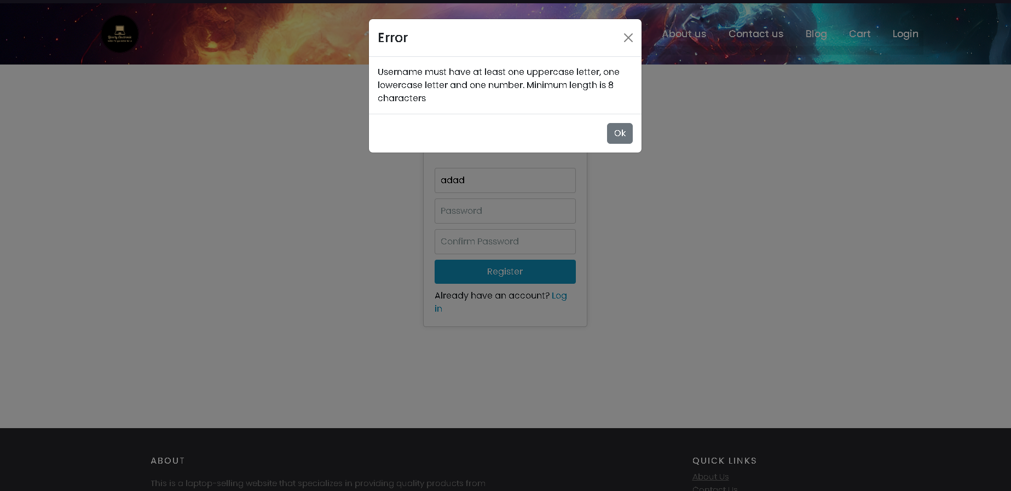

When wrong format password:

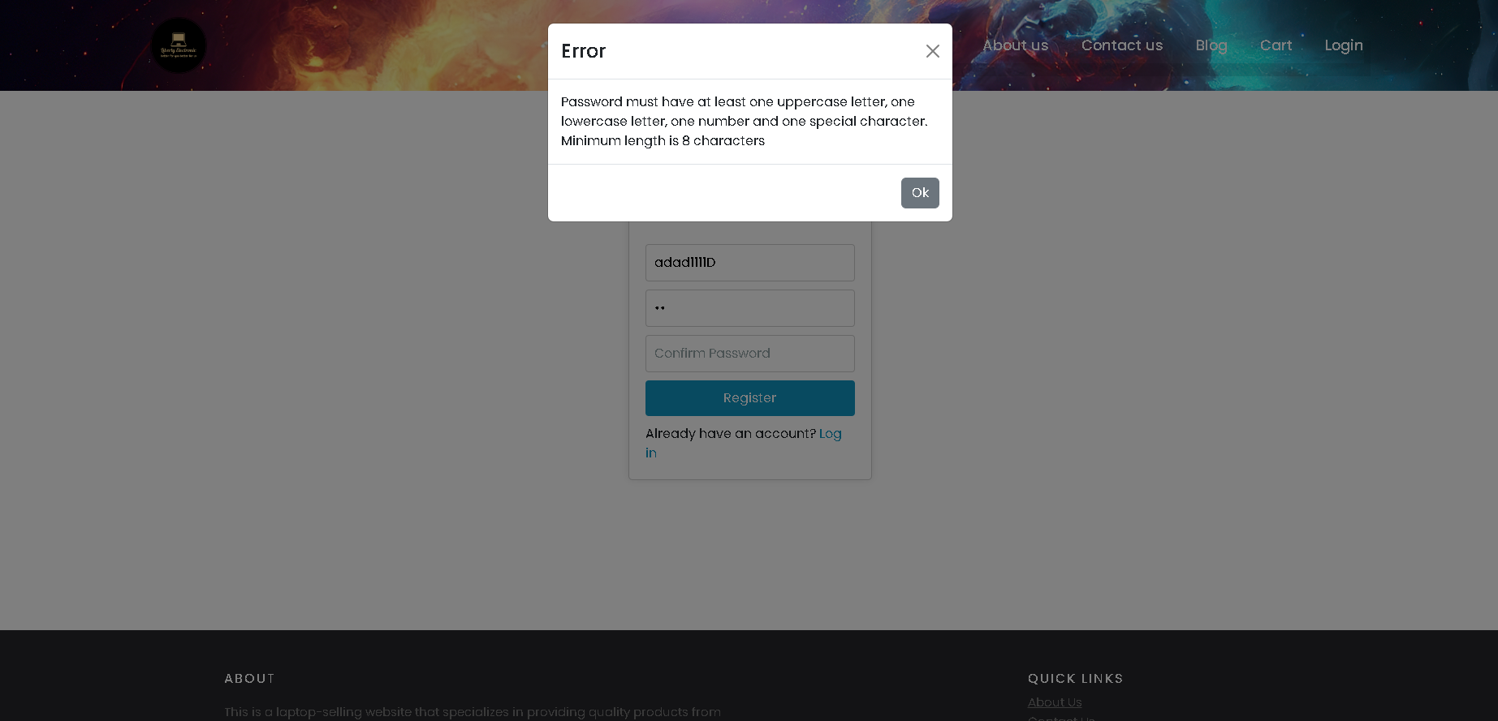



**1**

**3**

**2**

**4**

|  |  |  |  |
| --- | --- | --- | --- |
| **No.** | **Type** | **Discription** | **Validation** |
| 1 | Input | Information needed for login | Required username |
| 2 | Input | Information needed for login | Required password |
| 3 | Click | Submit login | Required username and password |
| 4 | Click | When clicked , it leads to register page | Register page navigate |

-Reponsive web :

-Home:

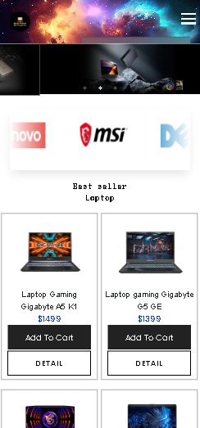

-Product:

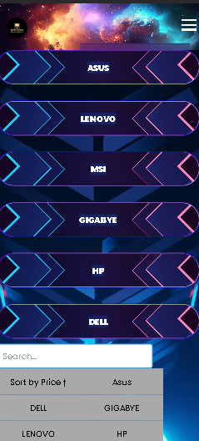

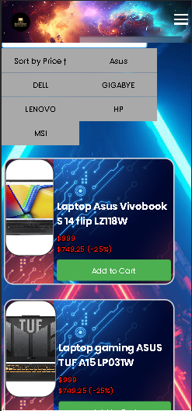

-Product Detail:

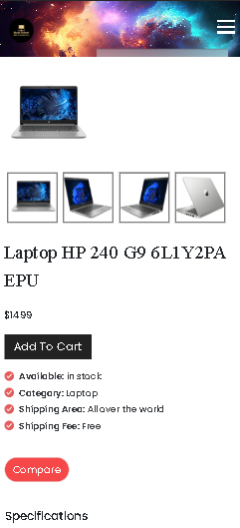

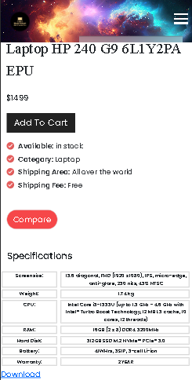

-Cart:

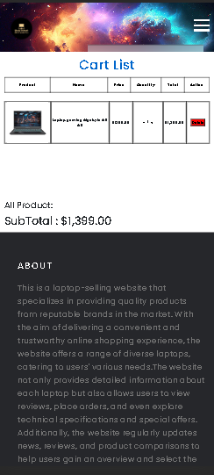

-About us:

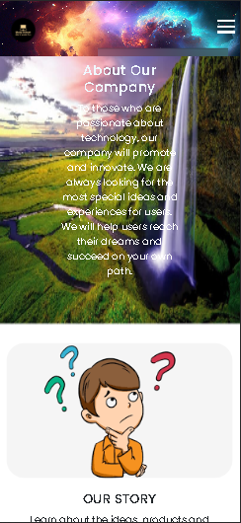

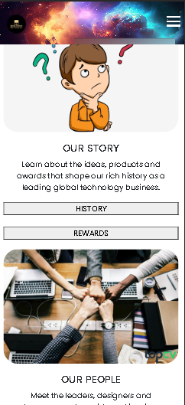

-Contact us:

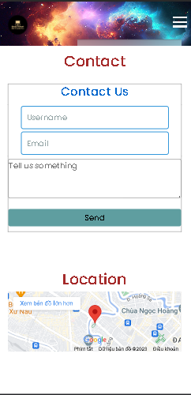

-Blogs:

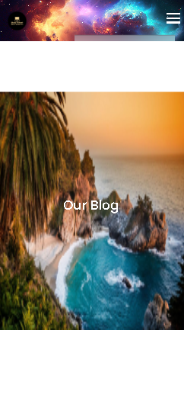

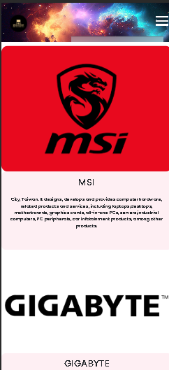

Task sheet

|  |  |  |  |  |  |  |  |
| --- | --- | --- | --- | --- | --- | --- | --- |
| No | Member | Contents | Page Name | Activity Plan | Date of Preparation of Activity Plan | | |
| Planed Start Date | Actual Start Date | Actual End Date | Status |
| 01 | Nguyễn Võ Minh Dũng | Cart | cart | 27/11/2023 | 30/11/2022 | 18/12/2023 | 100% |
| Product Detail | details | 27/11/2023 | 30/11/2023 | 18/12/2023 | 100% |
| 02 | Võ Phạm Thành Long | Menu |  | 27/11/2023 | 30/11/2023 | 18/12/2023 | 100% |
| Product | product | 27/11/2023 | 30/11/2023 | 18/12/2023 | 100% |
| Compare | compare | 27/11/2022 | 30/11/2023 | 18/12/2023 | 100% |
| 03 | Lê Thành Trung | Homepage | index | 27/11/2023 | 30/11/2023 | 18/12/2023 | 100% |
| Login/Register | login, register | 29/11/2023 | 30/11/2023 | 18/12/2023 | 100% |
| Css | All pages | 29/11/2023 | 30/11/2023 | 18/12/2023 | 100% |
| Responsive | All pages | 29/11/2023 | 30/11/2023 | 18/12/2023 | 100% |
| 04 | Nguyễn Ngọc Tuấn | Contact | contact | 29/11/2023 | 30/11/2023 | 18/12/2023 | 100% |
| About | about | 29/11/2023 | 30/11/2023 | 18/12/2023 | 100% |
| Blog | blogs | 29/11/2023 | 30/11/2023 | 18/12/2023 | 100% |